* SERVO MOTOR :-

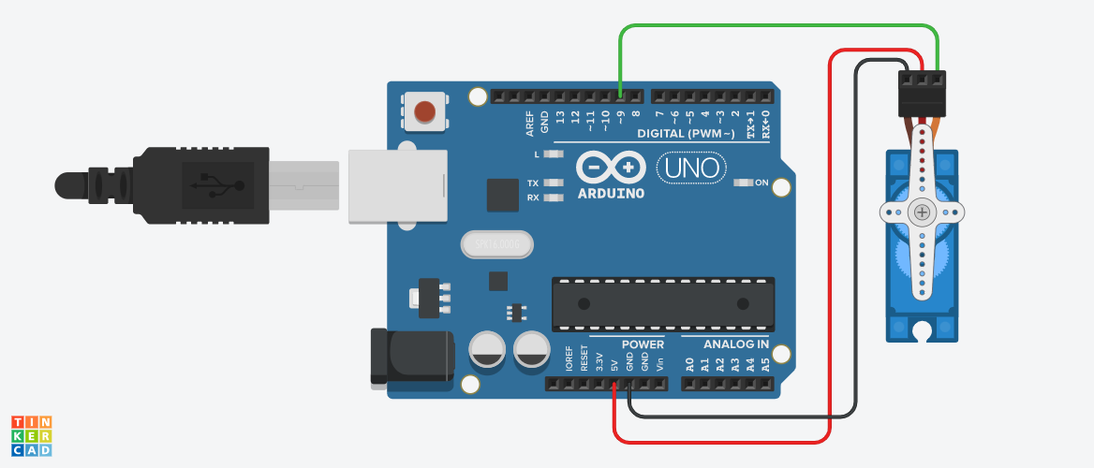

**Circuit diagram**

* **Description :-**

This project is based on **SERVO MOTOR**. Servo motor used to **control the position of objects, rotate objects, move legs, arms or hands of robots, move sensors** etc. with high precision. Servo motors are small in size, and because they have built-in circuitry to control their movement, they can be connected directly to an Arduino.

* **Application :-** 
  + - * + At Industry like Pharmaceuticals company
        + In Robotics.
        + Industrial Production.
        + Elevator Technology.
* **Working Principle:-**

Servo motor works on **PWM (Pulse width modulation) principle** means its angle of rotation is controlled by the duration of applied pulse to its Control PIN. Basically servo motor is made up of DC motor which is controlled by a variable resistor (potentiometer) and some gears.

* .**Circuit Connection :-**

Connect the Ground of the Servo motor to the GND of Arduino and the other one signal pins to the pin 9 of Arduino. Power connection of servo motor is by Arduino VCC.

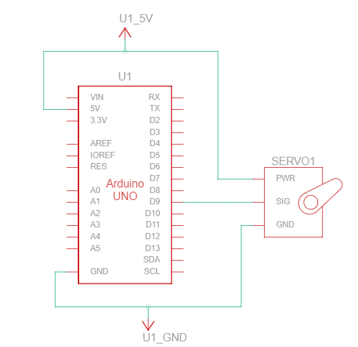

* Component List :-

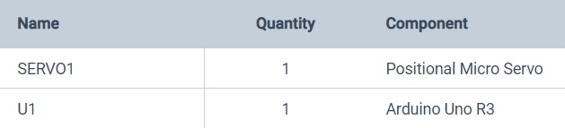

* **CODES :-**

// C++ code

//

#include <Servo.h>

Servo servo_9;

void setup()

{

servo_9.attach(9, 500, 2500);

}

void loop()

{

servo_9.write(90);

delay(1000); // Wait for 1000 millisecond(s)

servo_9.write(0);

delay(1000); // Wait for 1000 millisecond(s)

}

* **BLOCKCODES :-**

